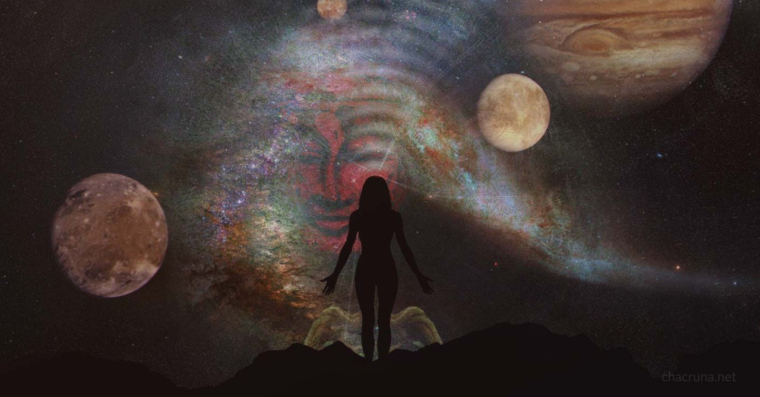

The World’s Best Practices for Integrating Ayahuasca
October 23, 2017

Kerry Moran, M.A., LPC

Working with the Amazonian plant medicine ayahuasca presents enormous psycho-spiritual challenges. In my experience as a meditator and psychotherapist, no other process comes close to ayahuasca’s power to activate body, psyche, and spirit, releasing that which has been trapped in the unconscious into the light of awareness. Each moment of bliss in ceremony can be offset by an equal amount of terror; it seems the heights to which one journeys are underpinned by the absolute dregs of experience. It requires a great deal of courage and no small amount of savvy to fathom this, to navigate skillfully through the process, and, especially, to apply the fruits of the journey to one’s life.
In certain Amazonian societies, the individual seeking healing would not drink the ayahuasca brew. Only the curandero would, embarking on a visionary journey that would yield the necessary information for treatment. Now we’ve entered a new era, where we sit in ceremony as direct participants. Unlike the indigenous people who have worked with ayahuasca for centuries, we come from a worldview that prizes detachment and devalues direct experience. We tend to be intellectually sharp but emotionally unaware, if not completely out of touch with our bodies and hearts. Many of us are disconnected from our families, ancestral roots, and communities. And now we embark on ritual work with a plant spirit that opens up the gates of the unconscious, the doors of perception? It’s a brave new world for us all.
Much has been written about the experience of drinking ayahuasca—the visions, the purging, the profound understandings that can arise. Not much has been said about the aftermath; in particular, the stage of work called “integration” that follows the ceremony. It’s essential to recognize that the healing ayahuasca initiates does not conclude with the end of ceremony; that, in many ways, the real work begins at this point. How we walk the post-ceremony path, the support we receive, and the tools and perspectives we apply, will determine the ultimate value of our work with the medicine.
Working with ayahuasca is a co-creative process. The medicine interacts synergistically with body, mind, and spirit in ways that are utterly unique to each individual. I am continually amazed by ayahuasca’s ability to pick the lock of the conceptual mind, releasing the contents of the personal unconscious and beyond. It liberates our inner wisdom in ways that are often surprising but always organic to our individual path. Quite often, it must first unearth our essence from the psychic debris of family imprints and unconscious patterning.

Levels of Transformation
At a very basic level, ayahuasca integration means cleaning up your act in support of your newly upgraded self. Job, relationships, diet, habits, mindset—all these are up for transformation in the weeks following ceremony.
A second aspect of integration involves shadow work. Ayahuasca is a potent activator of the unconscious, bringing buried traumas, forgotten experiences, and rejected aspects of self to the light. We need methods for first tolerating, then working with and understanding these. Integration, in large part, is the process of absorbing and digesting this raw material; quite literally, incorporating it into your consciousness. This inevitably changes your perspective on life, self, identity, and purpose.
As we continue, a third level of integration emerges: the task of bringing soul to the world, showing up as our true whole selves. We begin to cultivate a way of being that is in touch with what really matters. Our fractured modern psyches have been disconnected from Nature and one another, with consumerism and digital distraction stuffed into the cracks to assuage the pain of separation. Truly integrating our work with ayahuasca provides an opportunity to heal who we are as individuals, and as a species. As Robert Sardello wrote
We must bring our true selves into the world … The psychic starvation brought about by removing soul from the world produces insatiable greed, for when the world is no longer surrounded with soul a vast emptiness intervenes that must be filled.¹
At this deepest level, integration demands that we transform our way of being and working with ourselves, our perceptions, and the world. Through this process we move from blame to responsibility, from drama to dignity, from unconsciousness to awareness.
All three of these levels of integration require tools and practices to support transformation—practical ways to work with body, spirit, heart, and mind. At minimum, we need to know how to deal with difficult emotions and destructive mental patterns, and how to sustain a healthy body that is both grounded on Earth and connected with spirit. If we have any insufficiencies in these areas, ayahuasca will expose them. It’s not the medicine’s job to magically remedy these deficits; it’s our work—integration work—to grow into new ways of being.
It might be helpful to recognize that many of us are already walking the path of integration in our lives, and perhaps were long before we ever heard of ayahuasca. A basic definition of integration is “to combine two things so they become a whole.” We naturally integrate as we take in new information and generate new perspectives. Simply put, integration is the process of growth and evolutionary change—and humans have been doing this pretty much forever.

East, West, Indigenous
When we understand that integration is an innately human capacity, not something that’s exclusive to ayahuasca work, we are free to draw in wisdom tools from many cultures and times. We cast our net wide to find the support we need, seeking not as spiritual dilettantes, but as modern explorers pursuing what truly works for us here and now in life. What does integration mean from an Eastern perspective? What are the best integrative tools we can gather from the Western world? And what wisdom do indigenous societies have to offer?
Eastern Spirituality. Eastern spirituality offers many pathways to experience pure consciousness as the love, light, and wisdom of True Self, Buddha Nature, or Atman. The basic view is that our essence is already enlightened, although covered by obscurations. This can be particularly healing for refugees from the Christian mindset of original sin. To accept your starting point as purity, albeit obscured, feels profoundly different than constantly struggling to transcend your defective basic nature.
Eastern religions offer a multitude of practices to dissolve the separation created by the ego and reveal the light of the essential self. Buddhism gives us tools for wisdom and compassion: meditations to open and clarify the mind, and practices to unlock the heart. The wisdom traditions of India offer many meditational and devotional methods, including the incredibly comprehensive practices of yoga in all its forms. Taoism, too, has practices to cultivate subtle energy and align oneself with the cosmos.
All these are based on similar principles: that man, nature, and universe exist in fundamental harmony; that inner and outer, divine and human, are essentially one; that the universe and everything in it are expressions of a single fundamental reality; and that our limited, ego-identified sense of self is merely a contraction, a temporary forgetting, of this basic state. Non-dual traditions, like Advaita, Kashmiri Shaivism, Zen, and Dzogchen may be particularly valuable to Westerners seeking to expand their egocentric worldview. There is much more to glean from Eastern traditions: sophisticated methods of working with the psycho-spiritual body through yoga, tai chi, qigong, and aikido; an understanding of the subtle body and the energies that dance their way through the channels and chakras; mantra and yantra, mandala and mudra, cosmologies that open to other realms and universes; respect for karma, the vast web of cause and effect we are constantly weaving, and the understanding that the “soul,” non-existent though it ultimately is, has more than one life and inhabits more than one body through the spiritual evolution of reincarnation.
Western Viewpoint. From the Western perspective, we draw on depth psychology, with its appreciation of the unconscious and the transpersonal. The work of Carl Jung, James Hillman, and others offers profound wisdom for integrating ayahuasca experiences with insights on the shadow, the psychodynamics of projection and introjection, and the power of archetypes and symbolism.
Jung’s emphasis on wholeness rather than perfection is fundamental to the path of integration; so is Joseph Campbell’s elucidation of the “Hero’s Journey,” which draws on mythology from around the globe to reveal the collective unconscious at work. Depth psychology offers many ways to listen to the language of the soul as it speaks through dreams, images, symbols, and creativity. Journaling, art therapy, active imagination and dreamwork are all channels through which the unconscious can become more conscious; a process that lies at the heart of integration. Further useful perspectives can be gathered from somatic psychology, including the growing understanding of how to work with trauma in an embodied way, as in Somatic Experiencing and Sensorimotor Psychotherapy.
More resources come from the many contemporary non-dual spiritual teachers of the West. Adyashanti, A. H. Almaas, Catherine Ingram, Byron Katie, Eckhart Tolle, Matt Kahn, Jeff Foster, and many more, all speak of the direct experience of reality as fundamental wholeness, free of identification and concepts. Rooted in Eastern spiritual traditions, this is wisdom presented in modern form.
Finally, from the West we can draw on the astonishing perspectives revealed by quantum physics. Here, the mechanistic worldview explodes into an understanding of a holographic universe, in which apparently discrete particles are actually streaming waves of probability, and conceptual categorization collapses into a realm where all things are non-locally united in an invisible, indivisible whole.
Indigenous Viewpoints. Indigenous worldviews are embodied by thousands of traditional cultures on every inhabited continent. Even Europe has its indigenous wisdom traditions, though these have been largely destroyed; first, by the Church; then, the modern religion of scientific materialism. Through the indigenous perspective, we come to understand the natural world as sacred and vibrantly alive. Rituals for connecting with nature and ways to heal through it pervade the indigenous practices of shamanism with their spirit journeys, divination, and healing techniques, and animals, protectors, and totems. Here again, there is an appreciation of dreams and an understanding of the fluidity of human identity and our interconnection with the whole.
Indigenous perspectives are not so much religions as ways of perceiving and relating to this Earth, and the worlds beyond. Diverse indigenous cultures—Maori, Shipibo, Yupik, Lakota, and thousands more—are deeply familiar with the unique spirits, plants, and powers of their homelands. The plant spirit of ayahuasca has been collaborating with indigenous peoples of the Upper Amazon for a very, very long time.
One thing indigenous peoples understand very well is how everything is interconnected. This unbroken sense of connection with nature—the recognition that we humans are organically interwoven into the fabric of nature and cosmos—is perhaps the most significant gift. The Quechua people of Peru understand this as ayni, “sacred reciprocity,” a way of honoring the relationship between humans and the larger sentience of the world, and seeking to live in balance with it. Modern culture has lost the sense of reciprocity with nature that infuses traditional cultures, and the ensuing hubris threatens the entire planet.
The indigenous worldview comes surging back in through ayahuasca; part of the healing that reconnects us to a larger matrix. Post-ceremony, it is very common to feel a new sense of belonging to nature, along with a responsibility to protect creation and use its gifts wisely. The understanding that the Earth is alive, that creation is intelligent, and we are part of the web of life: these are some of the many gifts that come from working with ayahuasca.
In this process, we are healing our fragmented modern minds. Ayahuasca’s work takes place on many levels, not least in repairing the Cartesian split of mind/body and man/nature. The medicine reconnects brain with body, a valuable contributor, but no longer the master. In reuniting with nature, we are reweaving ourselves back into the matrix of life in a way that is urgently, desperately needed.
Eastern, Western, or indigenous; all three perspectives provide ways for us to open up to something greater than our conscious minds, be it Self, the unconscious, or the universe. Humans are part of the bigger picture, but only part. From all these perspectives we gain clues as to how to work with integration. We draw in all sorts of possibilities and examine them for what is most useful to our particular situation. There is always room for more on the path of growth. The integration process does not end—ever. It is the ongoing process of life moving into further complexity and deeper simplicity. And it is up to us to live it, to make it real.

Acknowledgments
Thanks to Matthew Watherston of The Temple of the Way of Light for seeding the idea for this article and sharing some valuable perspectives.

References
- Robert Sardello, Facing the World with Soul: The Reimagination of Modern Life, (Great Barrington, MA: Lindisfarne Books, 1991). ↩
- Retrieved from (http://chacruna.net/world-best-practices-integrating-ayahuasca/), on April 13, 2018

